# Spring Data Exam

# Mountaineers

*Mountains are majestic natural landforms that rise prominently above their surroundings, often formed by tectonic forces or volcanic activity. They vary greatly in height, climate, and accessibility — from low hills to towering peaks like Mount Everest. Mountaineers are adventurers and athletes who climb mountains for exploration, sport, or scientific study.*

*Climbing mountains demands physical endurance, technical skill, and careful planning. Risks include altitude sickness, avalanches and extreme weather, but the reward is often unmatched views and personal achievement.*

## Functionality Overview

The application should be able to easily **import** hard-formatted data and **support functionalities** for also **exporting** the imported data. The application is called – **Mountaineers**.

Look at the pictures below to see what must happen:

* The home page before importing anything:

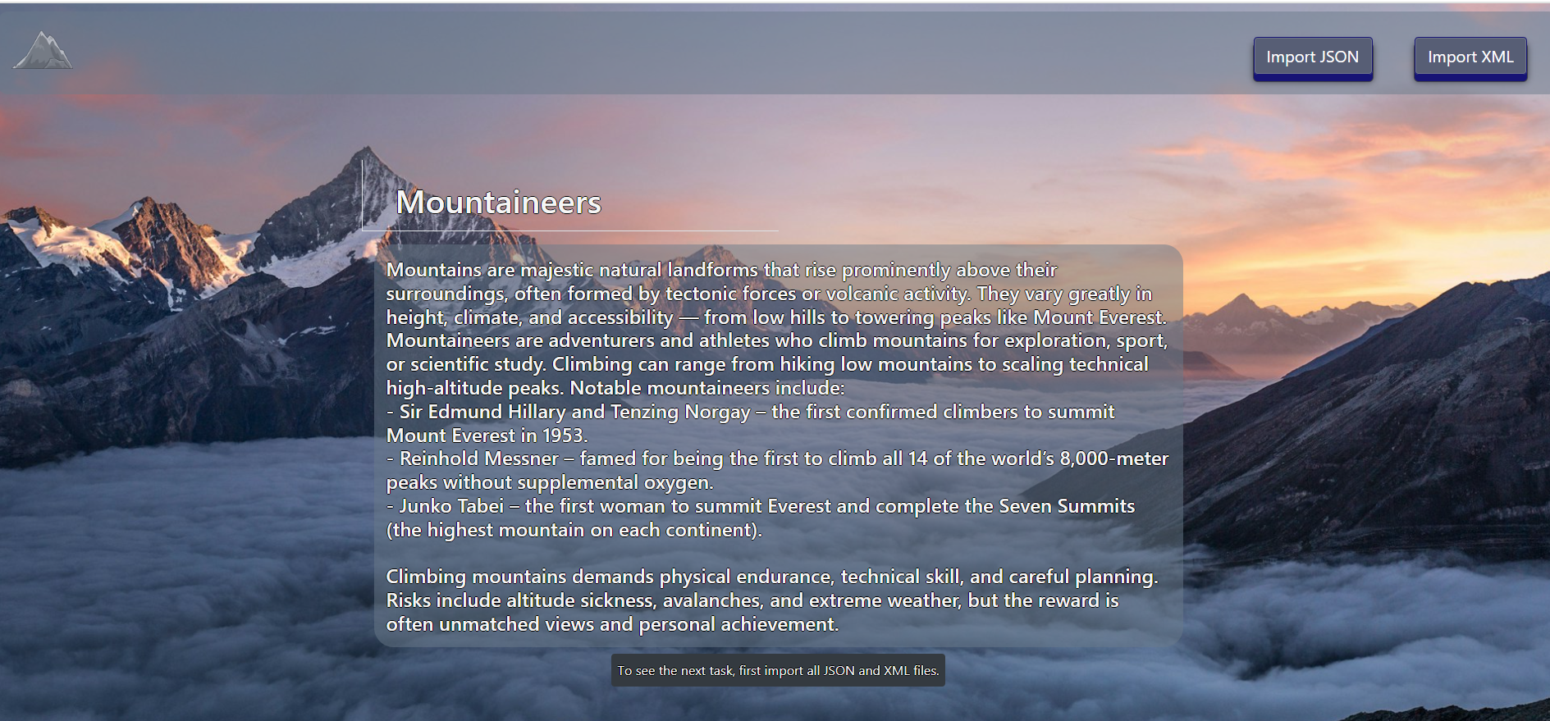

* The import JSON page before importing anything:

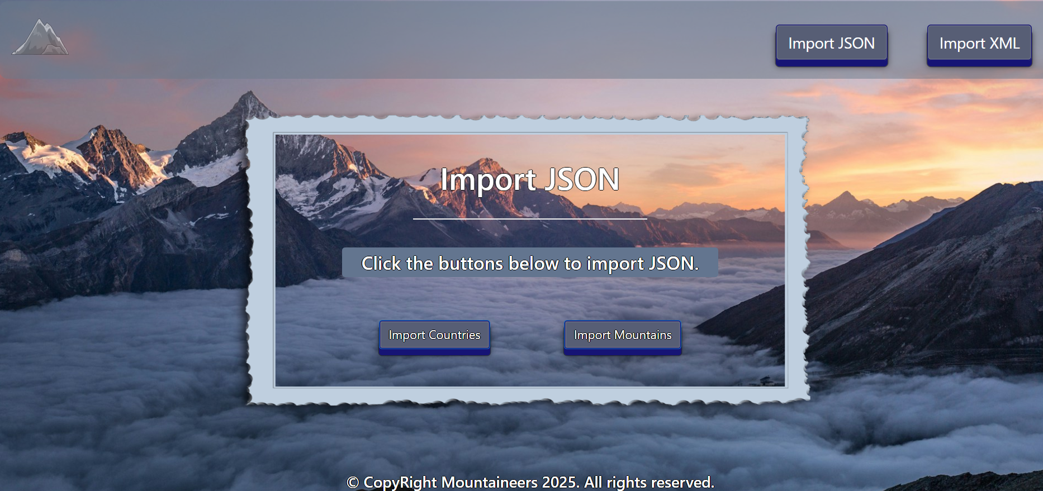

* Import the **countries** first:

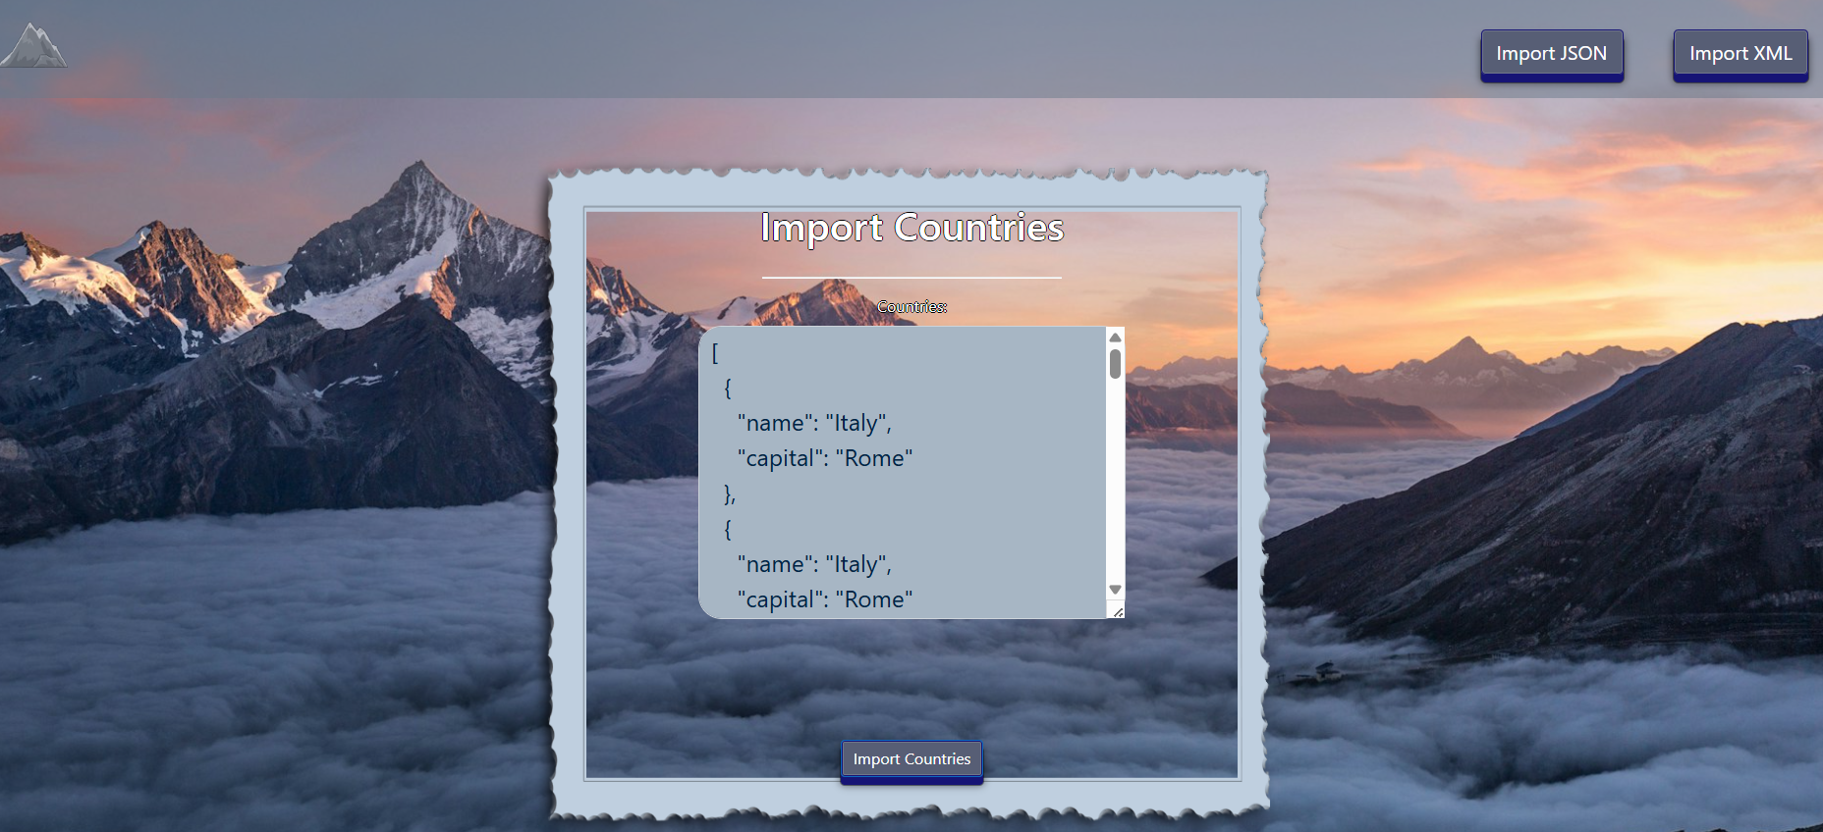

* Import the **mountains** second:

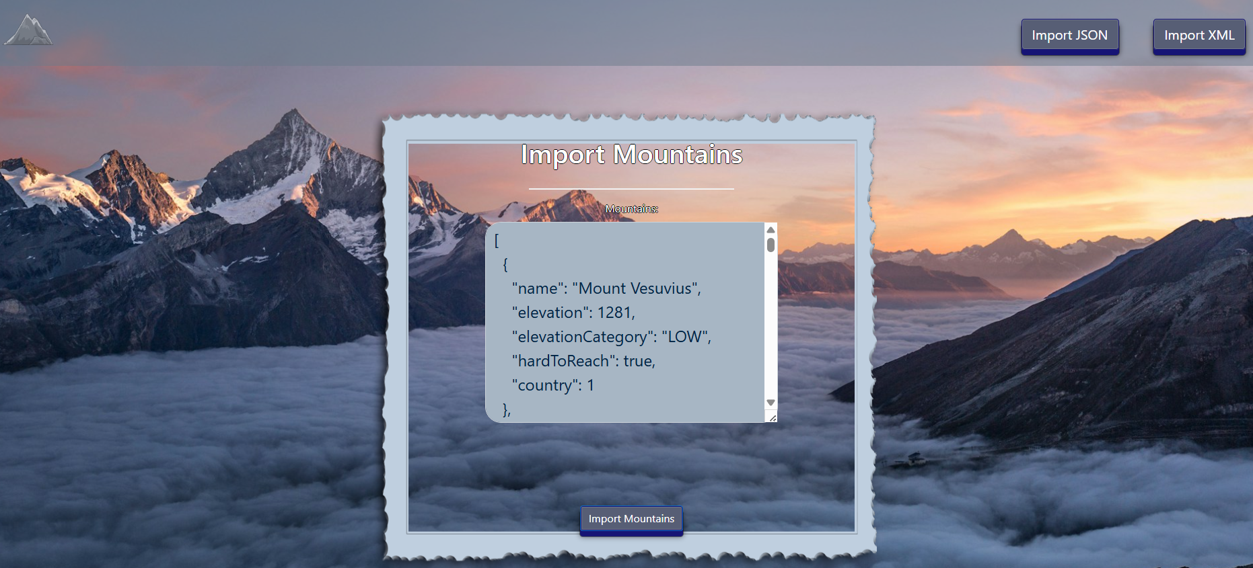

* The import JSON page after importing both files:

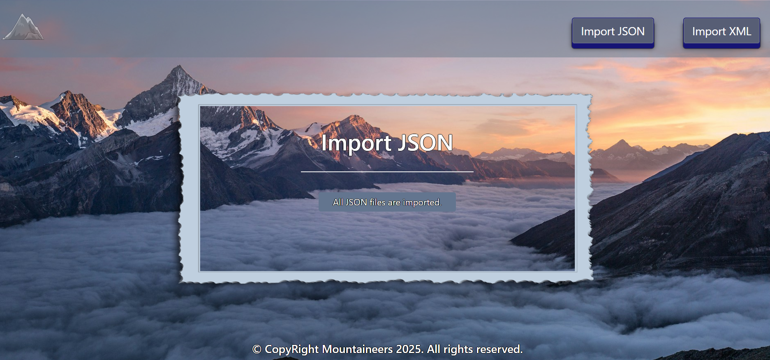

* The import XML page before importing the given data:

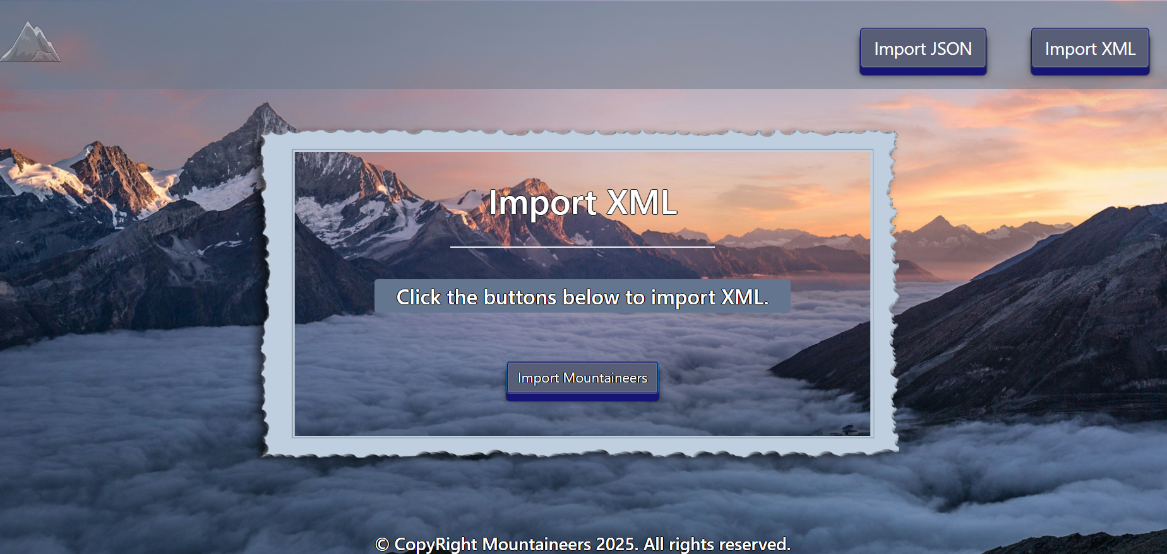

* Import the **mountaineers** data:

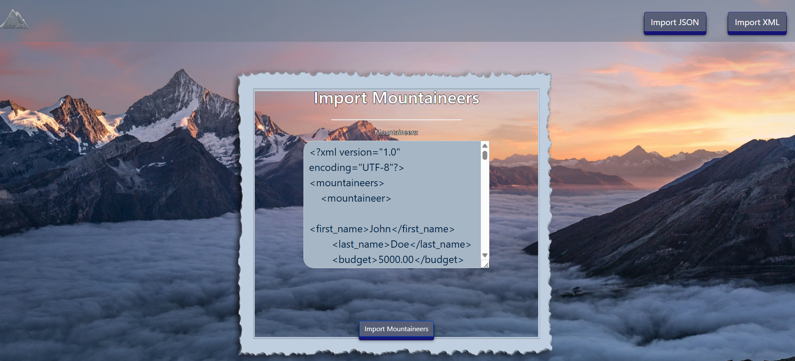

* After the XML import you will be redirected to home page and you will be able to export the mountains using the “Export mountains” button:

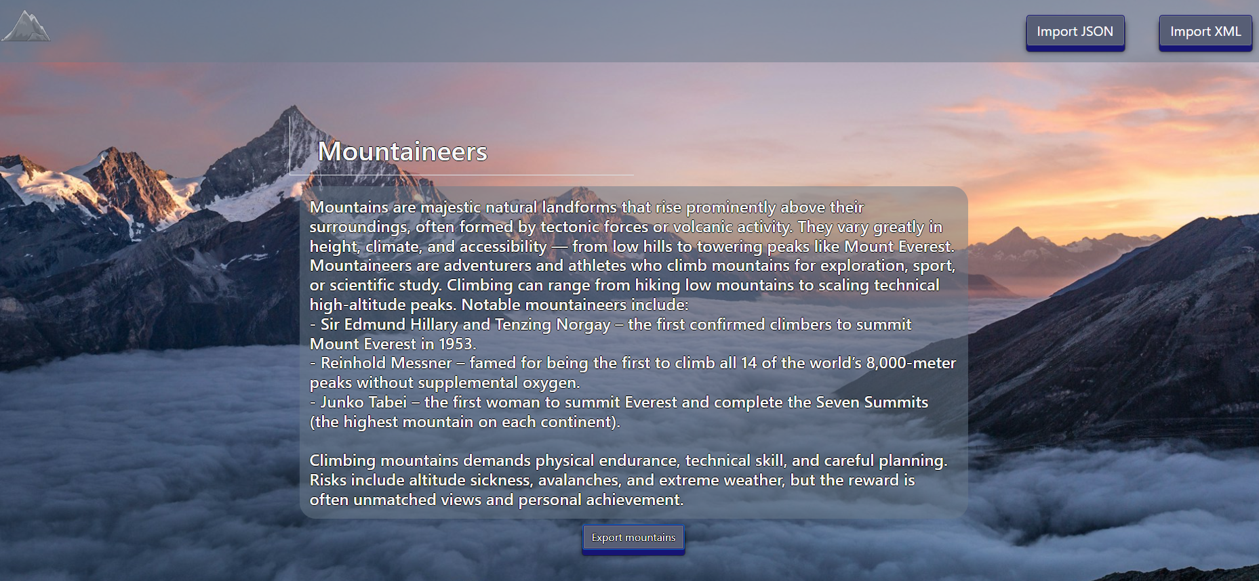

* Export all hard-to-reach mountains higher than 3000m:

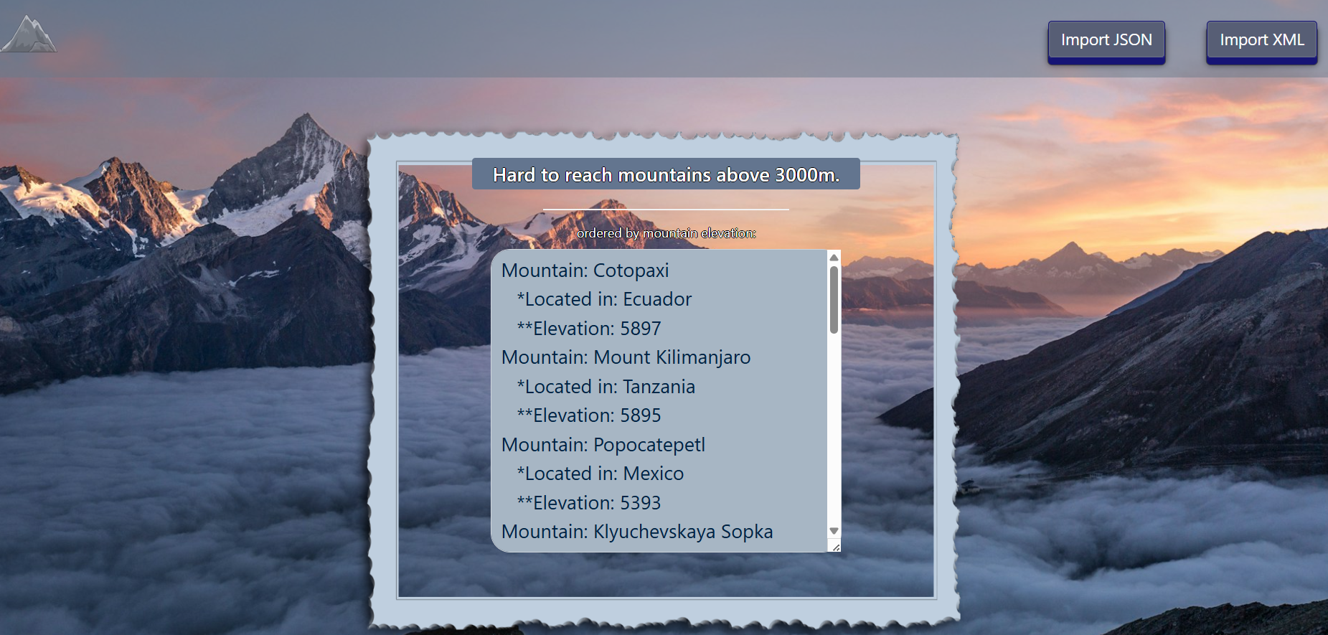

## Project Skeleton Overview

You will be given a **skeleton**, containing a **certain architecture (MVC)** with **several classes**, some of which are completely empty. The **Skeleton** will include the **files** with which you will **seed** the **database**.

**Don't change the skeleton.**

When submitting your project in Judge please make a **.zip** file only with **src** folder and **pom.xml** file.  
There are five problems in **Judge**:

**1. Database** will test the structure of your database.

**2. Service** will test the two methods **areImported()** and **readClassFromFile()** in every service class.  
**3. Import JSON** will test the logic of importing **JSON** files.

**4. Import XML** will test the logic of importing **XML** files.

**5. Export** will test the logic of the final **export** button which is in the **ExportController**.

Please note that the automated Judge system may take up to **5 minutes** to show results for each problem. We kindly ask you to be patient.

**Be aware that the Judge might not recognize the var keyword, leading to compilation errors.**

To help you ensure the correctness of your solutions and **gain immediate feedback**, we have included a set of **commented-out tests** within the provided skeleton project. These tests are designed to verify the functionality of the tasks you are required to implement.

## Model Definition

There are 3 main models that the **Mountaineers database** application should contain in its functionality.

We have provided you with an Entity-Relationship (ER) diagram that represents the database schema. The ER diagram displays the tables and their relationships, along with the field types for each table.

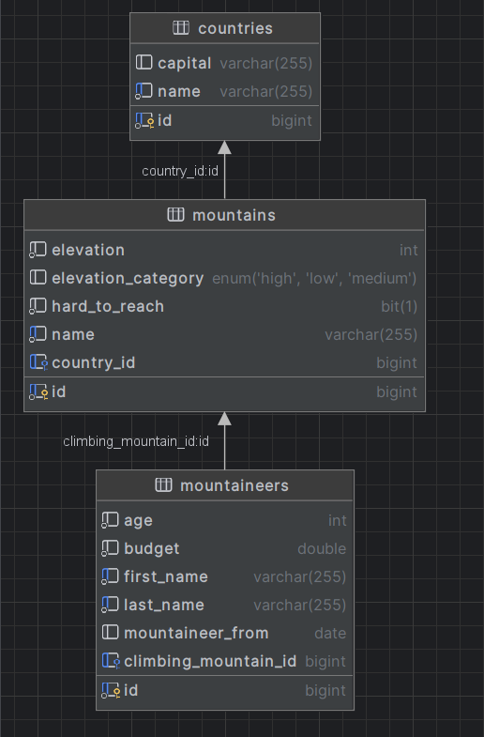

Ensure the **Java** code **validates** data against the specified constraints before persisting it into the database. Handle any validation errors gracefully and provide meaningful feedback to the users.

Design them most appropriately, considering the following **data constraints**:

### Country

* id – accepts **integer** values, a **primary identification field, and an auto incremented field**.
* name – accepts **char sequence** (between **3** to **30** both inclusive). The values are **unique in the database**. It **cannot be nullable**.
* **capital** - accepts **char** **sequence** (between **3** to **30** both inclusive). It can be nullable.
* Constraint: The countries table has a relation with the mountains table. It can be nullable.

### Mountain

* id – accepts **integer** values, a **primary identification field, an auto incremented field**.
* name - accepts **char** **sequence** (between **2** to **30** both inclusive). The values are **unique** in the database. It **cannot be nullable**.
* elevation - The highest point of the mountain. Accepts only **positive** numbers with maximum **4 digits**. It **cannot be nullable**.
* elevation category - categorization of the height of the mountains. **String** enumeration, one of the following – **LOW, MEDIUM, HIGH**. It can be nullable.
* **hard to reach** – accepts a true or false, representing whether the mountain is active or not. It **cannot be nullable**.
* **country** - the country in which the mountain is located.

Constraint: The mountains table has a relation with the countries table. It can be nullable.

### Mountaineers

* id - accepts **integer** values, a **primary identification field, an auto incremented field**.
* first name - accepts **char** **sequence** (between **2** to **30** both inclusive). **Unique,** it **cannot be nullable**.
* last name - accepts **char** **sequence** (between **2** to **30** both inclusive). **Unique,** it **cannot be nullable**.
* budget - accepts positive **Double** values. It **cannot be nullable**.
* age - accepts number values that are between **18** and **80** both inclusive. It **cannot be nullable**.
* mountaineer from - a date in the "**yyyy-MM-dd**" format. It can be nullable.
* climbing mountain – the mountain that the mountaineer climbs.

Constraint: The mountaineers table has a relation with mountains table. It can be nullable.

### Relationships

Your partners gave you a little hint about the more complex relationships in the database so that you can implement it correctly.

One **Mountaineer** may explore only one **Mountain**, but one **Mountain** may be explored by many **Mountaineers**.

One **Country** can have many **Mountains**, but one **Mountain** is located in only one **Country**.

#### Constraint

* Name the entities and their class members **exactly** in the **format stated** above.
* All fields are **NOT NULL** unless explicitly stated to be nullable.

## Data Import

Use the provided files to populate the database with data. Import all the information from those files into the database.

**You are not allowed to modify the provided files.**

**ANY INCORRECT** data should be **ignored** and a message should be printed:

**"Invalid {country/mountain/mountaineer}"**

**When the import is finished:**

**"Successfully imported {country/mountain/mountaineer} {countryName – capitalName/mountainName/full name}"**

**Judge** will only accept **file paths** in a specific format. When dealing with file paths for files, please adhere to the following format: "**src/main/resources/files/xml/file-name.xml**"

### JSON Import

Your new colleagues have prepared some JSON data for you to import.

#### Countries (countries.json)

##### Constraint

**If a country with the same name already exists in the DB return "Invalid country".**

**When the import is finished:**

**"Successfully imported country {countryName} – {capitalName}"**

|  |
| --- |
| **Country (countries.json)!** |
| [  {  "name": "Italy",  "capital": "Rome"  },  {  "name": "Italy",  "capital": "Rome"  },  {  "name": "Hawaii",  "capital": "Honolulu"  },  {  "name": "Japan",  "capital": "Tokyo"  },  {  "name": "USA",  "capital": "Washington"  },  {  "name": "Kabardino-Balkarian Republic",  "capital": "Nalchik"  },  {  "name": "Mexico",  "capital": "Mexico City"  },  {  "name": "Iceland",  "capital": "Reykjavik"  },  {  "name": "Russia",  "capital": "Moscow"  },  {  "name": "Tanzania",  "capital": "Dodoma"  },  ... |
| Successfully imported country Italy - Rome  Invalid country  Successfully imported country Japan - Tokyo  Successfully imported country USA - Washington  Successfully imported country Kabardino-Balkarian Republic - Nalchik  Successfully imported country Mexico - Mexico City  Successfully imported country Iceland - Reykjavik  Successfully imported country Russia - Moscow  Successfully imported country Tanzania – Dodoma  … |

#### Mountains (mountains.json)

##### Constraint

* **If a mountain with the same name already exists in the DB return "Invalid mountain".**
* **When the import is finished:**

**"Successfully imported mountain {mountainName}"**

* **The provided country ids will always be valid.**

|  |
| --- |
| **Mountain (mountains.json)** |
| [  {  "name": "Mount Vesuvius",  "elevation": 1281,  "elevationCategory": "LOW",  "hardToReach": true,  "country": 1  },  {  "name": "Mount Vesuvius",  "elevation": 1281,  "elevationCategory": "LOW",  "hardToReach": true,  "country": 1  },  {  "name": "Mauna Loa",  "elevation": 4169,  "elevationCategory": "HIGH",  "hardToReach": true,  "country": 2  },  {  "name": "Mount Fuji",  "elevation": 3776,  "elevationCategory": "MEDIUM",  "hardToReach": false,  "country": 3  },  {  "name": "Mount St. Helens",  "elevation": 2549,  "elevationCategory": "MEDIUM",  "hardToReach": false,  "country": 4  },  {  "name": "Mount Kilimanjaro",  "elevation": 5895,  "elevationCategory": "HIGH",  "hardToReach": true,  "country": 9  },  ... |
| Successfully imported mountain Mount Vesuvius  Invalid mountain  Successfully imported mountain Mauna Loa  Successfully imported mountain Mount Fuji  Successfully imported mountain Mount St. Helens  Successfully imported mountain Mount Kilimanjaro |

### XML Import

Your new colleagues have prepared some XML data for you to import.

#### Mountaineers (mountaineers.xml)

##### Constraint

* **If a mountaineer with the same full name (first name and last name) already exists in the DB return "Invalid mountaineer".**
* **If a mountaineer is climbing mountain that doesn't exist in the DB return "Invalid mountaineer".**
* **When the import is finished:**

**"Successfully imported mountaineer {first name} {last name}"**

|  |
| --- |
| **Mountaineers (mountaineers.xml)** |
| *<?*xml version='1.0' encoding='UTF-8'*?>*  <mountaineers>  <mountaineer>  <first_name>John</first_name>  <last_name>Doe</last_name>  <budget>5000.00</budget>  <age>55</age>  <mountaineer_from>1987-01-15</mountaineer_from>  <climbing_mountain_id>11</climbing_mountain_id>  </mountaineer>  <mountaineer>  <first_name>Jane</first_name>  <last_name>Smith</last_name>  <budget>5500.00</budget>  <age>60</age>  <mountaineer_from>1982-05-20</mountaineer_from>  <climbing_mountain_id>20</climbing_mountain_id>  </mountaineer>  <mountaineer>  <first_name>Michael</first_name>  <last_name>Johnson</last_name>  <budget>4800.00</budget>  <age>58</age>  <mountaineer_from>1984-09-10</mountaineer_from>  <climbing_mountain_id>33</climbing_mountain_id>  </mountaineer>  <mountaineer>  <first_name>Michael</first_name>  <last_name>Johnson</last_name>  <budget>4800.00</budget>  <age>58</age>  <mountaineer_from>1984-09-10</mountaineer_from>  <climbing_mountain_id>33</climbing_mountain_id>  </mountaineer>  <mountaineer>  <first_name>Emily</first_name>  <last_name>Brown</last_name>  <budget>5200.00</budget>  <age>56</age>  <mountaineer_from>1986-11-25</mountaineer_from>  <climbing_mountain_id>34</climbing_mountain_id>  </mountaineer> |
| Successfully imported mountaineer John Doe  Successfully imported mountaineer Jane Smith  Successfully imported mountaineer Michael Johnson  Invalid mountaineer  … |

Please be aware that due to variations in local settings on different computers, the representation of decimal numbers (Double) may differ. In some regions, the decimal separator is a comma (,), while in others, it is a dot (.).

Judge local settings represent all decimal numbers using a dot (.) as the decimal separator. *Locale.US*

## Data Export

Get ready to export the data you have imported in the previous task. Here you will have some complex database querying. Export the data in the formats specified below.

### Export all hard-to-reach mountains with elevation above 3000m from the Database

* Extract from the database, the **mountain name, location (country name) and elevation**.
* **Filter only mountains that are hard to reach and with an elevation of more than 3000m. Order the results descending by elevation.**
* Return the information in this format:

**"Mountain: {mountain name}**

**\*Located in: {country name}** (3 spaces indentation)

**\*\*Elevation: {elevation}** (3 spaces indentation)

**. . ."**

